Smart Shopping User Manual

By:

Cameron L’Ecuyer

Sneha Mishra

Ruthvic Punyamurtula

Navya Pillala

Table of contents:

1. Introduction
2. How to use the system with Screen dumps

2.1. Installation

2.2. Un-Installation

2.3. App Usage

2.3.1. Home page

2.3.2. Shopping page

2.3.3. Trends page

2.3.4. Recommendations page

2.3.5. Augmented Reality page

1. Error recognition and handling
2. Bugs and Deficiencies

Indexes:

Contents:

1. Introduction - Android App to help user enhance their shopping for furniture. This App allows user to do the following:

1.1 Login via registered email or Twitter credentials.

1.2 Shop using text or image analysis.

1.3 View the trends in the field of furniture based on the collected tweets.

1.4 Give recommendations to the user based on their calculated BMI.

1.5 Allows User to share the recommendations and suggestions on social media such as Facebook, Instagram, WhatsApp etc.

1.6 View the product in AR (augmented reality), this helps the User to check-out the product in any desired location wherever they place the marker.

1. How to use the system with Screen dumps -

2.1 Installation :

2.1.1 Download the ‘Smart Shopping’ app.

2.1.2 If new to the app, register using email ID or use an existing twitter credential.

Image

2.1.3 Log-in to the shopping app.

Image

2.1.4 Download the Unity .apk file

2.2 App Usage :

2.2.1 The default home page is the image analysis page, which the user can skip as per requirement.

2.2.2 If the User skips this page, they are redirected to the Shopping activity.

2.2.3 If the User is interested, they can click and image at run-time for image analysis.

2.2.4 Alternately, the user can select an existing image from the gallery for analysis.

2.2.5 The image analysis is done on the selected image and the description of the analysis is displayed to the User at the bottom of the screen.

Image

2.3 Shopping page

2.3.1 In shopping page, User can search for the product

2.3.2 User can also sort the products using the name or price

2.3.3 User can view the furniture trends by clicking on trends

2.3.4 The app also provides suggestions by giving user details as the input.

2.3.5 User can view the product by clicking on AR – Camera button in the shopping page

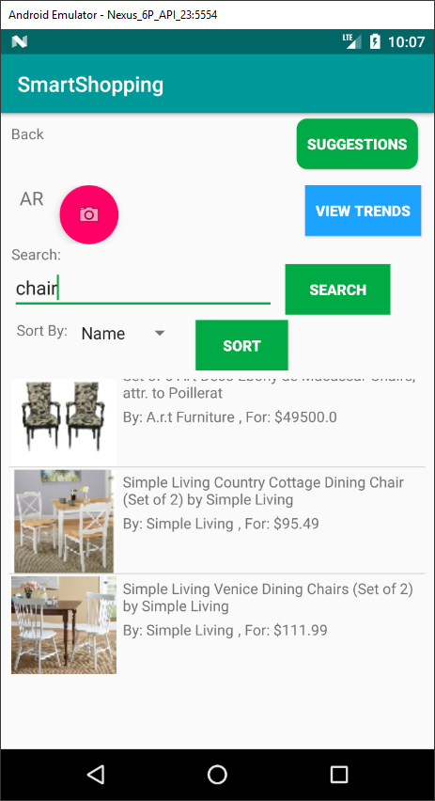

2.4 Trends page

2.4.1 User can view the shopping trends based on the furniture categories in this page

2.4.2 User can navigate back to the shopping page by clicking on the back button

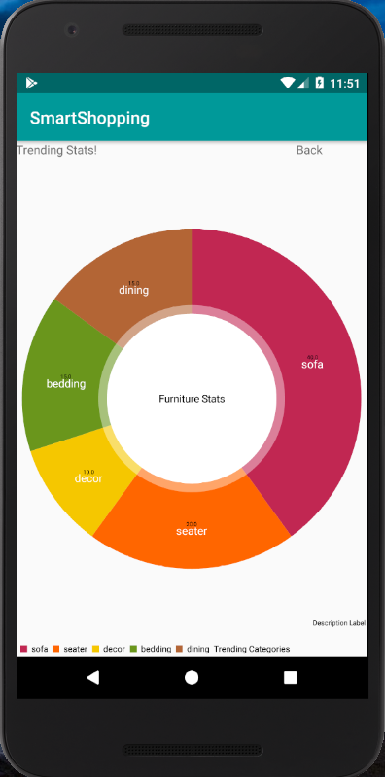

2.5 Suggestions page - BMI and social media

2.5.1 In the personal details, User has to enter name, age and phone number to get to the suggestions

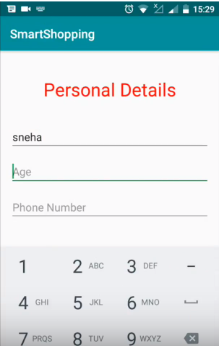

2.5.2 Then user has the option to set user height in “Feet” and weight in “KG”, to find the BMI

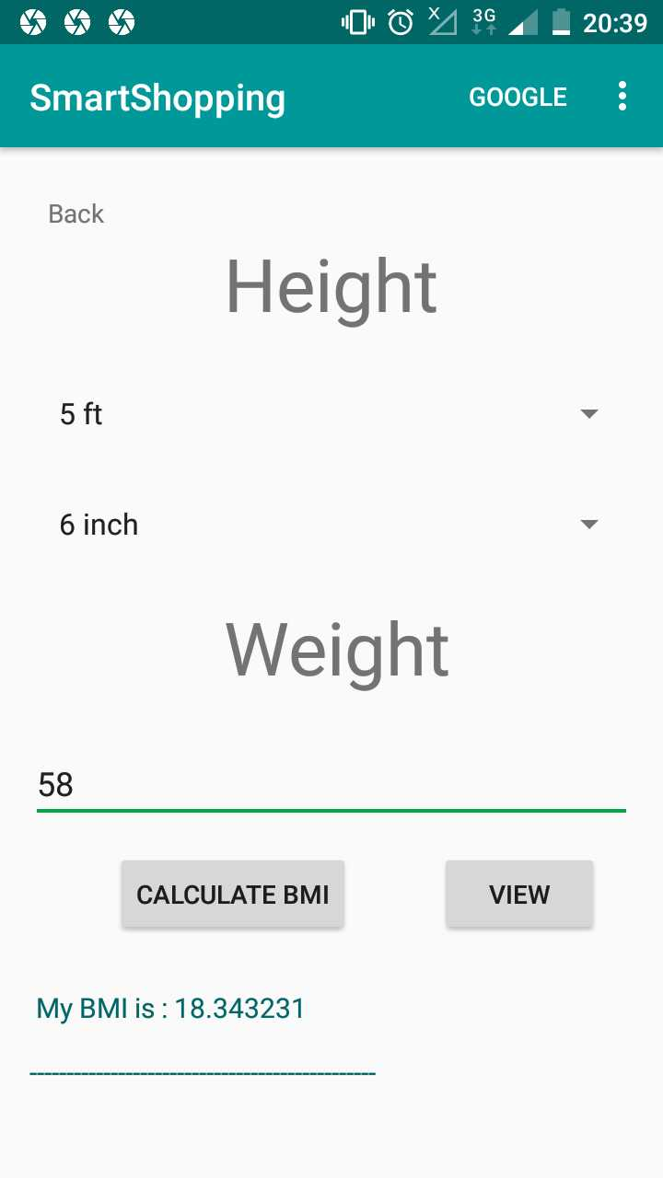

2.5.3 User can save the result or share the recommendations to the social media like Facebook, WhatsApp, Instagram etc.

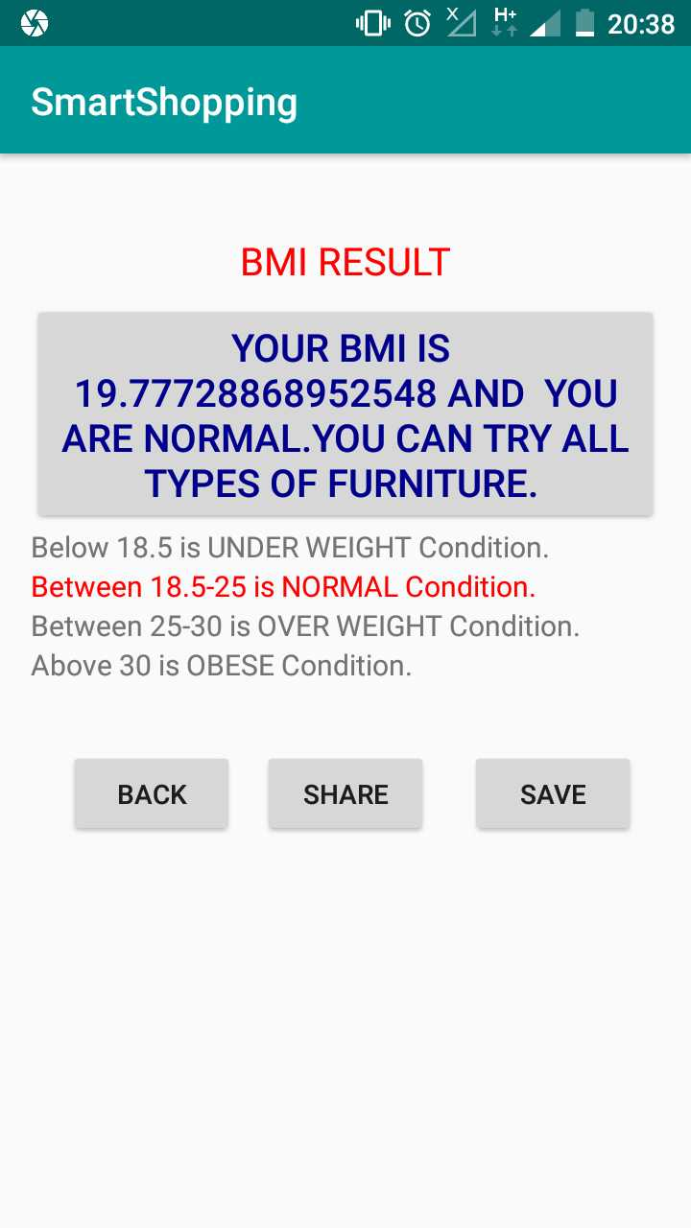

2.6 AR activity

User can view the product in Augmented Reality – 3D view anywhere by using the marker.

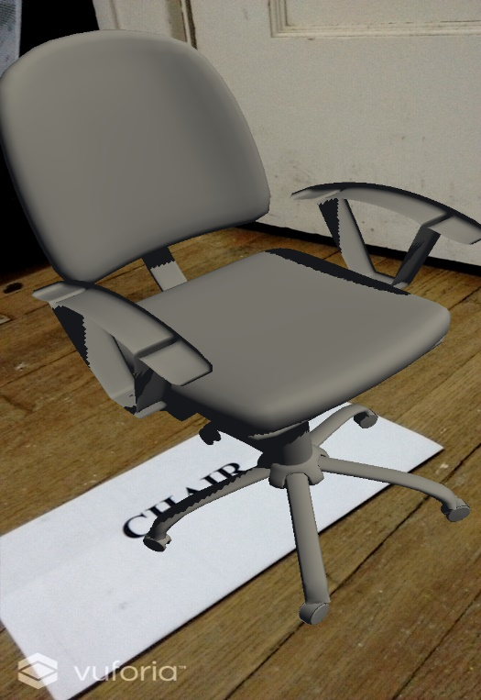

1. Error recognition and handling -

3.1 Once the User enters the AR mode to view any particular product, they cannot re-direct back to the shopping app. At this time the User can quit the app and re-open it to use the shopping app again.

3.2 The Image analysis returns the analysis report related to a fixed data set from the furniture field, if the image selected for analysis does not contain any furniture item, then the analysis report will be blank. In this case the User can modify or edit the search text as per their needs.

1. Bugs and Deficiencies -

4.1 App is not platform dependent, works only on android devices.

4.2 The password reset option is not provided to the user.

4.3 While registering user, we don’t confirm the password, so if the user needs to type carefully at the registration.

4.4 The trend analysis is based on the already collected twitter data and not done at run-time.

4.5 The trends when collected in real time slows down the app performance because of processing huge data

4.6 The shopping API returns only one image per product.

4.7 BMI part again requires user registration.

4.8 User cannot re-direct to the shopping app from the AR view.

4.8 Log-out option is only provided at the home page of the app.